Date: 10/28/25
Week: 2 - Create an Analysis Model for a Small Bed & Breakfast Reservation System

1)
Rubric Criteria:
Create UML use case diagram of 3-7 use cases 10%
Your Response:
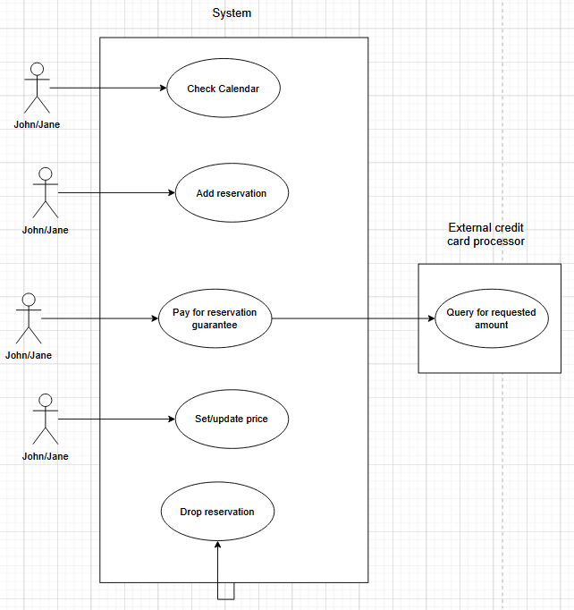

2)
Rubric Criteria:
Write use case sequence of events for each use case in the use case diagram 20%
Your Response:
Description: | Check calendar
Trigger: | Click a button (assumption)
Precondition: | Calendar is up-to-date
Flow: | Calendar appears set to current date (assumption) with current reservations displayed  User can click to change dates (assumptions)

Description: | Add reservation
Trigger: | Click a button (assumption)
Precondition: | Calendar is displayed
Flow: | Form opens with reservation details  User enters details  Price of room should appear when room number is selected (assumption)  (Note: Booked room cannot be selected)  User presses Save (assumption)
Postcondition: | Calendar is displayed with new reservation

Description: | Pay for reservation guarantee
Trigger: | Click a button (assumption)
Precondition: | Reservation is open, room number has been selected, room number has associated price in system (assumptions)
Flow: | Payment processing system opens  One day’s payment is calculated  User enters credit card number  Client’s credit card processor is queried for requested amount  Upon confirmation, reservation is marked as guaranteed (assumption)
Postcondition: | Success or error message is displayed (assumption)

Description: | Drop reservation
Trigger: | Daily system check, automatic (assumption)
Precondition: | Reservation is not marked as guaranteed AND reservation guarantee-by date is reached or passed
Flow: | Reservation is canceled  Cancellation message is sent to interested parties (assumption)
Postcondition: | Reservation is no longer in system

Description: | Set/update price
Trigger: | Click a button (assumption)
Precondition: | Room type exists in system
Flow: | User selects room type  Edit window appears (assumption)  User updates price  User clicks Save (assumption)
Postcondition: | Window appears with updated price, future reservations use new price

3)
Rubric Criteria:
Explain approach, steps, and rationale of the use case model 25%
Your Response:
I think better in words than diagrams, so I actually started with the use case specification writeup. As well as the information copied into step 2, I also kept track of actors, exceptions, questions I still have, and initial thoughts about the class diagram and database structure. I then translated it into the diagram for 1.
Most of the use cases involve John or Jane interacting with the system to make it do something, as per the requirement listing that the clients not be able to book their own rooms. I also added a use case that is just the system determining that a reservation needs to be dropped and doing so, which has no human actor, so I diagrammed it by starting the arrow from the system box itself. I know that credit card payments involve communication with the credit card processor, so I diagrammed that in as a separate system that the payment use case queries.

4)
Rubric Criteria:
Create UML class diagram 10%
Your Response:

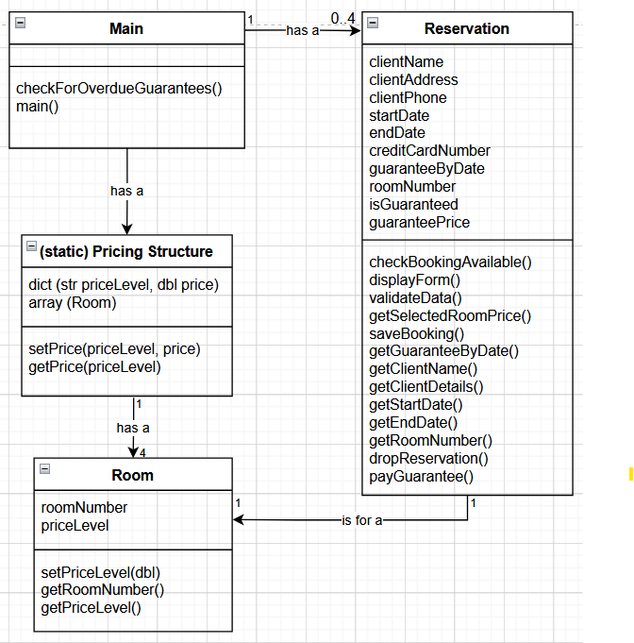

5)
Rubric Criteria:
Explain approach, steps, and rationale of the class diagram model 25%
Your Response:
I assume that a calendar class of some sort exists in whatever language we are working in and that I do not need to create (and therefore, diagram) this class. I assume the same for direct communication with the credit card processor.
Although this calendar class probably contains some sort of Reservation, I assume the need to inherit from it to personalize the fields. I added the form details as fields, and I made the assumption that the guarantee-by date is automatically calculated and stored as part of the reservation, so I added a field for that. The reservation class will need to interact with the user interface to collect the information, so I added a method to display the form and one to save the data (which essentially acts as the setter method for all the fields). In every calendar app I’ve ever used, the start and end dates can be edited from within the form, so I added a method to check again before saving that the room is available. I also added a validation method to run before the saving process completes, which will check that the correct data types have been entered, the end date is after the start date, etc. In order for the calendar interface to display the bookings, it will need to pull the dates and room number from the reservation, so I added getter methods for those as well as the client name, which seems like the sort of information one would want for reports or perhaps tooltips. Similarly, the guaranteeByDate needs to be accessible for the system to check if the reservation should be dropped. However, I decided that the personal identifying information of the client should be harder to access, and packaged those into one getClientDetails method to be called only when opening the reservation.
I then created the Room class, which naturally comes with a roomNumber and a priceLevel. I set getters for both, and also a setter for priceLevel, in case they one day decide to, e.g., make the medium priced room a high priced room.
My intuition is that rooms, price level (low, medium, high) and price should be two tables in a database. To put this into an OOP framework, I decided to create a static class called Pricing Structure with data structures to hold that information. I made a dictionary to allow one to take a price level and look up the price, with a setter and a getter method for the price. I also made an array to hold the four rooms. They shouldn’t need to add rooms, so a statically sized structure should be sufficient.
I assume there is a class that can be instantiated to create a recurring task. Then the main class can instantiate one to scan the room list in the Pricing Structure and check for reservations that have reached their guaranteeByDate. Presumably the main class in its main function will also initialize the GUI and read the pricing structure and calendar information from memory.

6)
Rubric Criteria:
Reflect on the learning experience and lessons learned 10%
Your Response:
I would have liked to be able to ask more questions about what exactly the customer is expecting. For example: are any of my assumptions false? Do the clients get a warning before their booking expires? Do John and Jane? Also, if I’d known what language this was in, I might’ve been able to research applicable standard libraries, which would give me more confidence in my class diagram.
I am still a little bamboozled by the disconnect between database use and object oriented modeling. I’ve done a fair amount of both, but somehow never managed to connect the two and I’m not sure I did it right. Is there a class in Java with a method that can query or update a database directly? In Python? I’ve somehow never been exposed to a programming language writing to long-term memory in any way other than creating an entire text file. For all of the form-to-database work I’ve done, it’s always been at a higher level, and I only needed to write code for the tweaks.

